**Torpedo7 opens for the first time in Palmerston North**

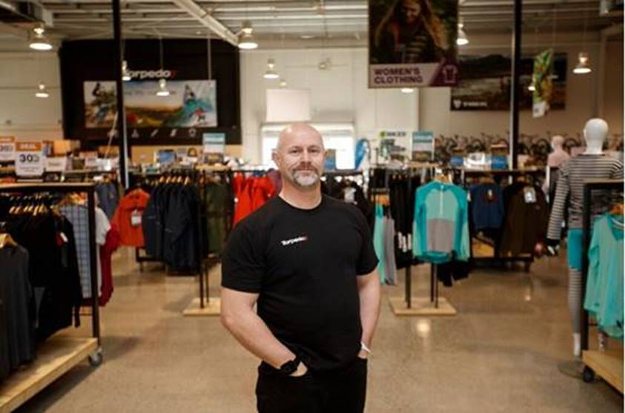

***Pictured: Torpedo7 Store Manager Phil Emerson at the new Palmerston North store.***

Leading Kiwi outdoor adventure brand Torpedo7 is set to open for the first time in Palmerston North tomorrow, bringing twelve new jobs to the region.

The 1400m² store located on Featherston Street is one of six new stores opening throughout the country this year as the brand goes from strength to strength.   
  
CEO Tim Edwards says they’re thrilled to open in Palmerston North and extend their store footprint across New Zealand.

“Our online store has proven popular in Palmerston North for some time so we’re excited to be able to offer a physical presence here and give people the opportunity to experience our amazing products, alongside some of our specialist in-store services."

"It’s great to see so many passionate people keen to work with us and it’s clear the community here doesn't shy away from adventure," says Edwards.

The spacious new store will offer an array of outdoor adventure gear from leading local and international brands, including Torpedo7’s own private label range. Customers will also have access to a specialist onsite bike and snow workshop led by a team of experienced mechanics - providing gear repair, safety checks and expert advice.

Palmerston North follows two other store openings for the retailer this year including its new flagship location in Auckland. Further stores are planned for Te Rapa, Manukau and New Plymouth this side of Christmas.

"The response from customers particularly to our bricks and mortar locations has been really encouraging. People are loving the ability to experience our products first hand and benefit from the specialist knowledge of our team.

“We look forward to building on this and making more of our stores available to Kiwis as we open in new regions in the coming year." Says Edwards.

Store Manager Phil Emerson says the community is pumped for the opening.   
  
“Lots of people in the area already shop online with us and we’re excited to provide the full in-store experience now too, with services like our bike shop.”

“It’s also been great to see the enthusiasm for team roles in the store. It’s clear the community loves adventure and we’ve got a passionate team on board who know everything there is to know about the walking tracks, bike trails and snow and surf spots nearby.”

**Store Hours:**

Monday – Wednesday: 9am to 5.30pm, Thursday: 9am to 7pm, Friday to Sunday: 9am to 5.30pm

**Store Address:**

Torpedo7, [250 Featherston Street, Palmerston North 4410](https://maps.google.com/?q=250+Featherston+Street,+Palmerston+North+4410&entry=gmail&source=g)